

**Jordan University Of Science And Technology.**

**Course Name : Object Oriented Software Analysis & Design (UML).**

**Project Name : University Registration System (URS).**

**Project Semester : First Semester 2018/2019.**

**Subject : Report Of University Registration System (URS).**

**Project Members :**

1. **Qussai Al-HajjHasan 121075.**
2. **Mohammad Al-Omari 127466.**
3. **Sarah Shuqairat 113343.**

**Dr : Mohammad Al-Hammouri.**



**First Step : We are build the Use Case Diagram.**

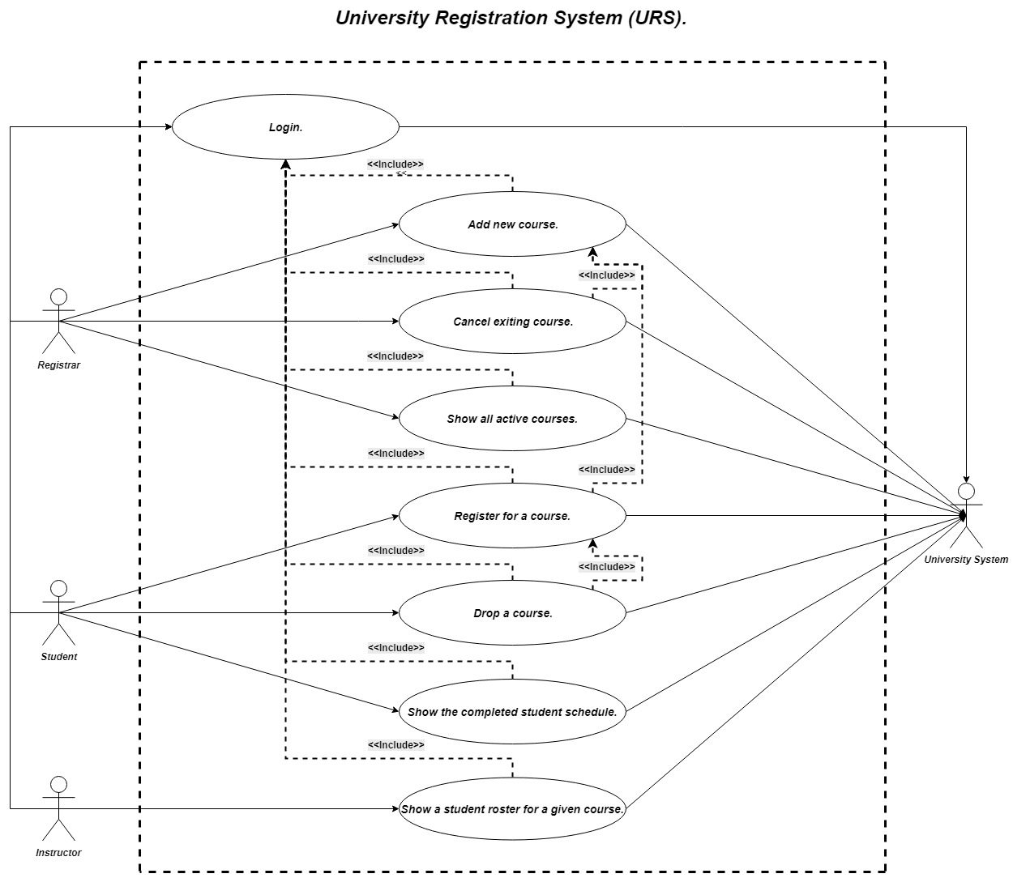

**Second Step : We are build the Description.**

1-Registrar Functions :

1. Add New Course Function :

|  |  |
| --- | --- |
| **Number :** | **1.** |
| **Name :** | **Add New Course.** |
| **Summary :** | **Registrar add new course to course schedule.** |
| **Preconditions :** | **Registrar has logged into University Registration System.** |
| **Postconditions :** | **Course added to course schedule successfully.** |
| **Primary Actor(s) :** | **Registrar.** |
| **Secondary Actor(s) :** | **University system , Instructor.** |

|  |  |  |
| --- | --- | --- |
| **Main Scenario :** | **Step :** | **Action :** |
|  | **1** | **User log into the system as Registrar.** |
|  | **2** | **System requests the course ID.** |
|  | **3** | **System requests the course time.** |
|  | **4** | **System requests the course credit hours.** |
|  | **5** | **System requests the course capacity.** |
|  | **6** | **Number of registered students is set to 0** |
|  | **7** | **The system must fetch and display full information of all instructors from the database.** |
|  | **8** | **The registrar enters the id of the desired instructor.** |
|  | **9** | **A new course is added to the database.** |
|  | **10** | **The registrar log out from the system.** |
|  | **11** | **System returns user to the main page.** |
| **Extensions :** | **Step :** | **Branching Action :** |
|  | **2a** | **System notifies user that wrong ID or User name entered.** |
|  | **2b** | **System returns user to the main page.** |
|  | **9a** | **System notifies registrar that the entered instructor ID is wrong.** |
|  | **9b** | **System returns registrar to repeat enter the instructor ID.** |

1. Cancel Existing Course Function :

|  |  |
| --- | --- |
| **Number :** | **2.** |
| **Name :** | **Cancel Existing Course.** |
| **Summary :** | **Registrar Cancel Existing Course from the course schedule.** |
| **Preconditions :** | **Registrar has logged into University Registration System.** |
| **Postconditions :** | **Course Canceled from course schedule Successfully.** |
| **Primary Actor(s) :** | **Registrar.** |
| **Secondary Actor(s) :** | **University system , Instructor , Student.** |

|  |  |  |
| --- | --- | --- |
| **Main Scenario :** | **Step :** | **Action :** |
|  | **1** | **User log into the system as registrar.** |
|  | **2** | **The system displays full information of all courses that have less than 3 students.** |
|  | **3** | **The registrar enters the id of the desired course to be cancelled.** |
|  | **4** | **The system removes the record of the course from the database.** |
|  | **5** | **The system removes all registration records associated with the course from the database.** |
|  | **6** | **The registrar log out from the system.** |
|  | **7** | **System returns user to the main page.** |
| **Extensions :** | **Step :** | **Branching Action :** |
|  | **2a** | **System notifies user that wrong ID or User name entered.** |
|  | **2b** | **System returns user to the main page.** |
|  | **3a** | **System notifies registrar that more than 3 student registered the course.** |

1. Show All Active Course Function :

|  |  |
| --- | --- |
| **Number :** | **3.** |
| **Name :** | **Show All Active Course.** |
| **Summary :** | **System displays all active course in course schedule.** |
| **Preconditions :** | **Registrar has logged into University Registration System.** |
| **Postconditions :** | **Registrar has Shown All Active (non-cancelled) Courses.** |
| **Primary Actor(s) :** | **Registrar.** |
| **Secondary Actor(s) :** | **University System.** |

|  |  |  |
| --- | --- | --- |
| **Main Scenario :** | **Step :** | **Action :** |
|  | **1** | **User log into system as Registrar.** |
|  | **2** | **The system displays all active courses.** |
|  | **3** | **The registrar log out from the system.** |
|  | **4** | **System returns user to the main page.** |
| **Extensions :** | **Step :** | **Branching Action :** |
|  | **2a** | **System notifies user that wrong ID or User name entered.** |
|  | **2b** | **System returns user to the main page.** |

2- Student Functions :

1. Register A Course Function :

|  |  |
| --- | --- |
| **Number :** | **4.** |
| **Name :** | **Register A Course.** |
| **Summary :** | **Add new course to the certain student schedule.** |
| **Preconditions :** | **Student has logged into University Registration System.** |
| **Postconditions :** | **Student has added course and received confirmation of that.** |
| **Primary Actor(s) :** | **Student.** |
| **Secondary Actor(s) :** | **University System, Instructor.** |

|  |  |  |
| --- | --- | --- |
| **Main Scenario :** | **Step :** | **Action :** |
|  | **1** | **User log into system as student.** |
|  | **2** | **The system displays all active courses that have seat.** |
|  | **3** | **The student enters the ID of the Course to be registered.** |
|  | **4** | **The system will add the course to student schedule and update the database.** |
|  | **5** | **The system add student to the instructor course schedule and update the database.** |
|  | **6** | **The system adds the number of course credit to student total credit.** |
|  | **7** | **The student log out from the system.** |
|  | **8** | **System returns user to the main page.** |
| **Extensions :** | **Step :** | **Branching Action :** |
|  | **2a** | **System notifies user that wrong ID or User name entered.** |
|  | **2b** | **System returns user to the main page.** |
|  | **4a** | **System notifies student that the course already in the schedule or there is another course at the same time.** |
|  | **4b** | **System returns student to repeat enter the course ID.** |

1. Drop A Course Function :

|  |  |
| --- | --- |
| **Number :** | **5.** |
| **Name :** | **Drop A Course.** |
| **Summary :** | **Withdrawal of the course from the certain student schedule.** |
| **Preconditions :** | **Student has logged into University Registration System.** |
| **Postconditions :** | **Student has withdrawn course and received confirmation of that.** |
| **Primary Actor(s) :** | **Student.** |
| **Secondary Actor(s) :** | **University system , Instructor.** |

|  |  |  |
| --- | --- | --- |
| **Main Scenario :** | **Step :** | **Action :** |
|  | **1** | **User log into the system as student.** |
|  | **2** | **The system displays the course schedule of the logged-in student .** |
|  | **3** | **The student enters the ID of the course to be dropped.** |
|  | **4** | **The system removes the corresponding registration record from the database.** |
|  | **5** | **The system removes the student from the instructor course schedule.** |
|  | **6** | **The system decreasing the number of registered course by 1 in course schedule.** |
|  | **7** | **The student log out from the system.** |
|  | **8** | **System returns user to the main page.** |
| **Extensions :** | **Step :** | **Branching Action :** |
|  | **2a** | **System notifies user that wrong ID or User name entered.** |
|  | **2b** | **System returns user to the main page.** |
|  | **4a** | **System notifies student that wrong course ID entered.** |
|  | **4b** | **System returns student to repeat enter the course ID.** |

C)Show All Completed Student Schedule :

|  |  |
| --- | --- |
| **Number :** | **6.** |
| **Name :** | **Show All Completed Student Schedule.** |
| **Summary :** | **View all registered course in the certain student schedule.** |
| **Preconditions :** | **Student has logged into University Registration System.** |
| **Postconditions :** | **The completed Student schedule displays.** |
| **Primary Actor(s) :** | **Student.** |
| **Secondary Actor(s) :** | **University system.** |

|  |  |  |
| --- | --- | --- |
| **Main Scenario :** | **Step :** | **Action :** |
|  | **1** | **User log into the system as student.** |
|  | **2** | **The system displays the course schedule of the logged-in student .** |
|  | **3** | **The system displays the total hours of the registered course.** |
|  | **4** | **The student log out from the system.** |
|  | **5** | **System returns user to the main page.** |
| **Extensions :** | **Step :** | **Branching Action :** |
|  | **2a** | **System notifies user that wrong ID or User name entered.** |
|  | **2b** | **System returns user to the main page.** |

3- Instructor Functions :

1. Show A Student Roster For A Given Course.

|  |  |
| --- | --- |
| **Number :** | **7.** |
| **Name :** | **Show A Student Roster For A Given Course.** |
| **Summary :** | **View the list of students enrolled for a particular course.** |
| **Preconditions :** | **Instructor has logged into University Registration System.** |
| **Postconditions :** | **The list of registered students for the course is displayed.** |
| **Primary Actor(s) :** | **Instructor.** |
| **Secondary Actor(s) :** | **University system.** |

|  |  |  |
| --- | --- | --- |
| **Main Scenario :** | **Step :** | **Action :** |
|  | **1** | **User log into the system as Instructor.** |
|  | **2** | **The system displays all courses that the logged-in instructor teaches.** |
|  | **3** | **The instructor enters the ID of the desired course.** |
|  | **4** | **The system displays the full information of all students who register in the course.** |
|  | **5** | **The instructor log out from the system.** |
|  | **6** | **System returns user to the main page.** |
| **Extensions :** | **Step :** | **Branching Action :** |
|  | **2a** | **System notifies user that wrong ID or User name entered.** |
|  | **2b** | **System returns user to the main page.** |
|  | **4a** | **System notifies instructor that wrong course ID entered.** |
|  | **4b** | **System returns instructor to repeat enter the course ID.** |

**Third Step : We are build the Class Diagram.**

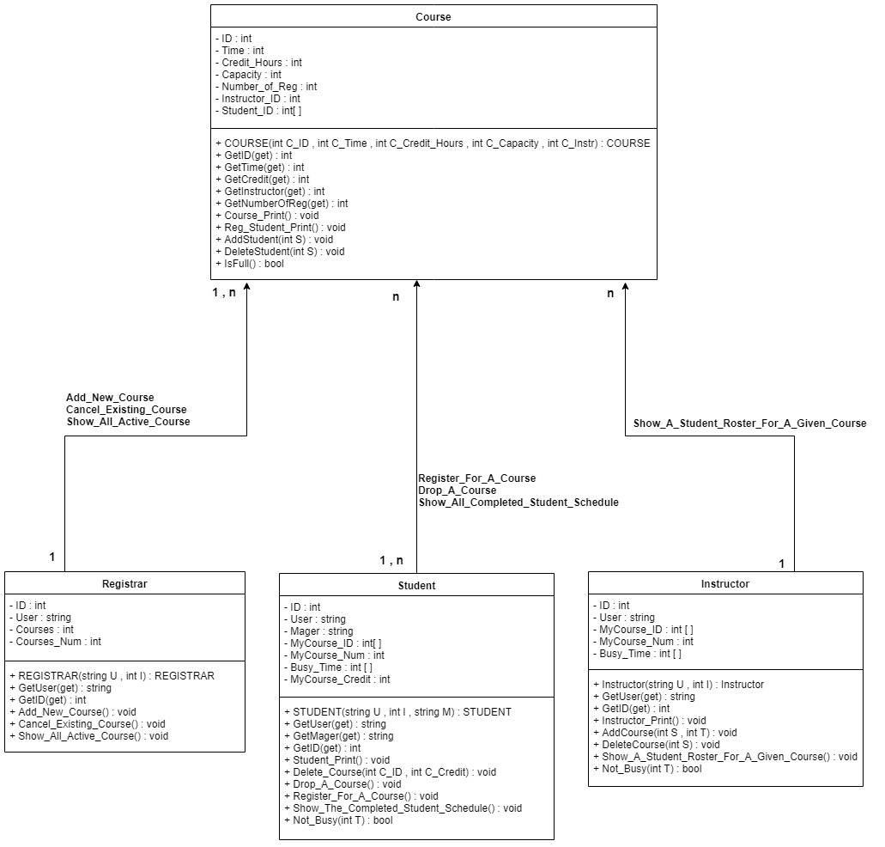

**Fourth Step : We are build the Sequence Diagram.**

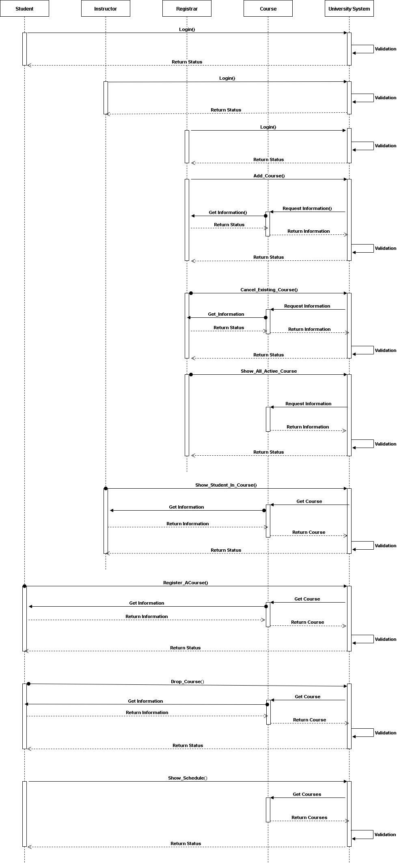

**Fifth Step : We are write a Code using C# Language.**

